BUSINESS Rental Vehicle Program with National Car and Enterprise Rent-A-Car

- National preferred for Airport travel
- Enterprise preferred for Local travel

BUSINESS TRAVEL

- Global Contract ID to use (BUSINESS TRAVEL ONLY) – for Both Brands:
- XZ32145 – Lucas Oil
- Note: Vehicle Protection included when code is used on business rentals (damage waiver and supplemental liability protection).

Steps:
- Enroll in Emerald Club (loyalty program) (www.nationalcar.com/enroll/XZ32145)
  - Recognized at Both Brands
- If you already have an Emerald Club number, be sure to connect your Emerald Club profile to your company contract to access any new benefits and ensure your information is current.
- If you do not already have an Emerald Club number, click on your company's exclusive enrollment link (above).
- Select “Enroll Now”.
- Confirm your new company name is listed above and select “Sign In”.
- Sign in with your Emerald Club Number & Password.
- Confirm your company name is listed and select “Update".
  - If you have a loyalty program with any competitor (Air, Hotel, or Car) – and you are in the 2nd or 3rd tier program – We will Status Match you into our program
  - Use this Status Match link – Having additional Status – may help with vehicle availability: https://status.emeraldclub.com

Reserve Vehicles:
- Business Travel (Reserve via Normal Reservation Process
  - Make sure your Emerald Club number is loaded into your travel profile for both National and Enterprise

Enterprise-Rent-A-Car:
- If employee is not an Enterprise Plus member, they can login using their Emerald Club membership login.
- Employees will need to select “add Emerald Club”, shown below, and this will prompt you to login with your Emerald Club login.
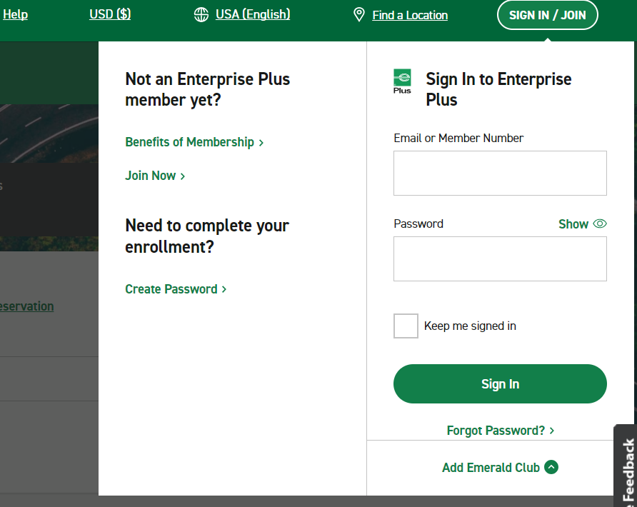

LEISURE/PERSONAL TRAVEL

Rental Vehicle Program with National Car and Enterprise Rent-A-Car
- Employees can use the following account number for leisure/personal rentals: XZB4838.
- This allows employees to rent vehicles for personal use at rates equal to the business rental rates.
- When renting for personal use, employees must change the contract number during the reservation process, shown below in the National and Enterprise-Rent-A-Car sections. Note: once the account number above is entered, the account number will say “LUCAS OIL PRODUCTS INC LEISURE”

National Car Rental
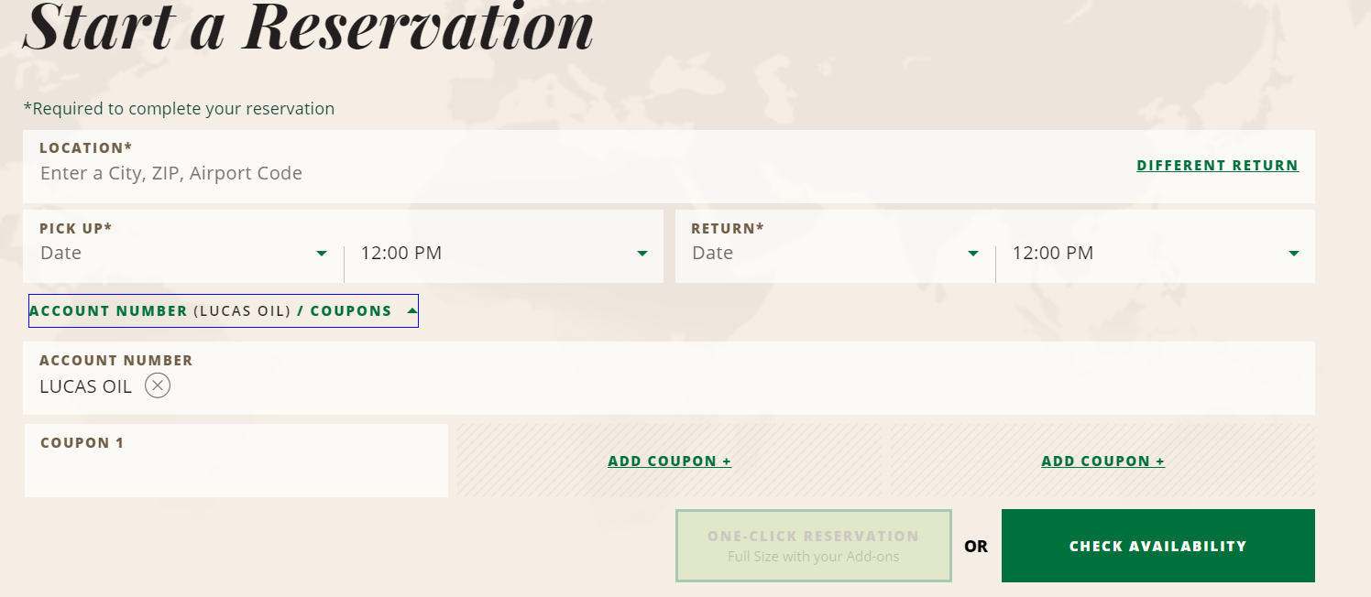

Enterprise-Rent-A-Car
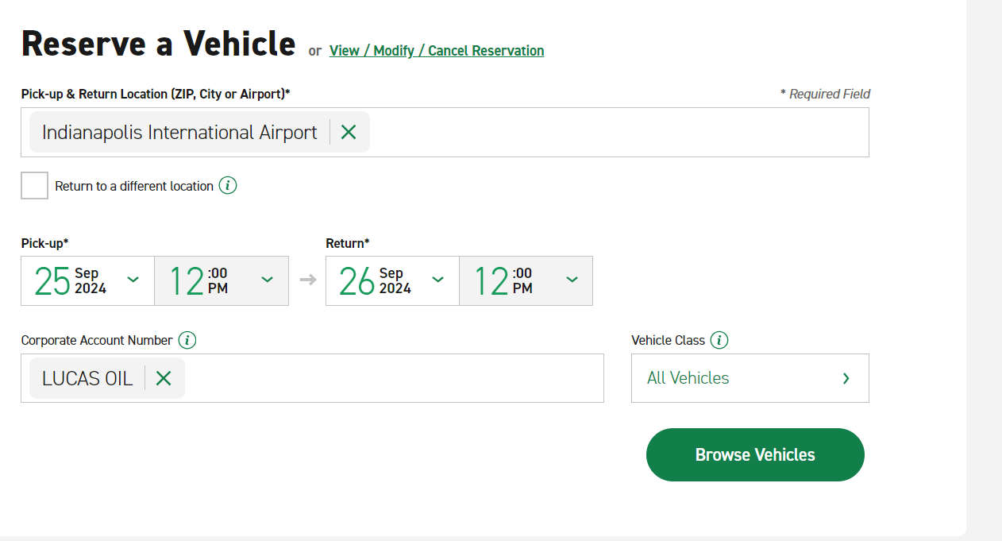

- Note, vehicle protection (damage waiver and liability protection) DOES NOT apply, and the employee either needs to have their own personal vehicle insurance to cover the rental or they can opt to purchasing the rental car insurance.

